Nome: Igor de Matos da Rosa
Matrícula: 20103930

1.4)
R = 10kΩ
C = 1000µF
τ= R * C = (10000) * (1000 * 10^−6) = 10s
Vc(t) = Vs * (1 − e^−(t/τ))
6,3 = 10 * (1 - e^ -(t/10))
e^-(t/10) = 0,37
t = −10*ln(0,37) =~ 10 s
1.5)
9 = 10 * (1 - e^ -(t/10))
e^-(t/10) = 0,1
t = −10*ln(0,1) = 10*2,3026 =~ 23,0 s

1.6)
3,6 = 10 * (1 - e^ -(t/10))
e^-(t/10) = 0,64
t=4,4628

1.7)
1 = 10 * (1 - e^ -(t/10))
e^ -(t/10) = 0,9
t = 1,0536

2.1)
τ= R * C = (10000) * (1000 * 10^−6) = 10s
2.5)
Vc(t) = 0,5 * V0​ * e^−(t/τ)
ln(0.5) = −(t/τ)
τ = RC

R = -(t / (C * ln(0.5))
R = - (5 / (10*10^-6 * ln(0.5))
R = 721347.52044 Ω

3.3)
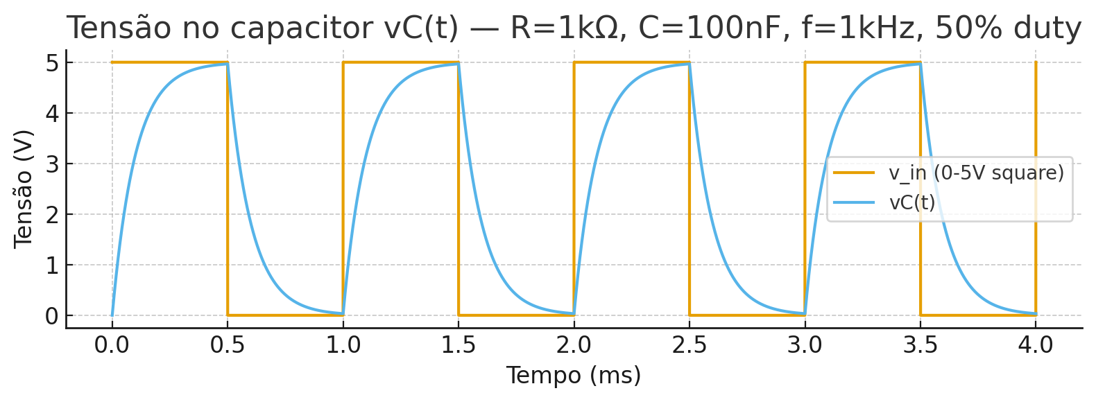
3.5)
